Puzzle - Slide Potentiometer

Introduction

This slide potentiometer is a linear variable resistor with a total resistance of 10k. When you move the lever from one side to the other, its output voltage will range from 0 V to the VCC you apply. It has four Puzzle pins, 3 of which are connected to VCC, GND and the ADC IN on the slide, while the remaining pin is connected to a green indicator LED. You can use the indicator LED to visually display the change on the potentiometer.

Features
- 30 mm long slide length
- Linear resistance taper
- Puzzle compatible

Specification

Item | Min | Typical | Max | Uint
Voltage | 3.3 | 5.0 | 30 | VDC
Current | -- | -- | 30 | mA
Dimension | 24x60 |  |  | mm
Net Weight | 8.6 |  |  | g
Rotational life | >15,000 |  |  | cycles
Total resistance | 10 |  |  | KΩ
Stroke length | 30 |  |  | mm
Total resistance tolerance | +/- 20 |  |  | %

Usage
This slide potentiometer is a linear variable resistor with a total resistance of 10k. When you move the lever from one side to the other, its output voltage will range between 0 V to VCC you apply.
1. Connect the module to the Analog port 0 of Puzzle - Basic Shield using the 4-pin Puzzle cable.
2. Plug the Puzzle - Basic Shield into Arduino.
3. Plug the Puzzle - Slide potentiometer onto the Arduino/duinofun; Connect the board to PC using USB cable.

Application
Copy and paste code below to a new Arduino sketch. Then upload the code to Arduino. Please click here if you do not know how to upload.

int adcPin = A0; // select the input pin for the potentiometer
int ledPin = A1; // select the pin for the LED
int adcIn = 0; // variable to store the value coming from the sensor

void setup()
{
Serial.begin(9600); // init serial to 9600b/s
pinMode(ledPin, OUTPUT); // set ledPin to OUTPUT
Serial.println("Sliding Potentiometer Test Code!!");
}

void loop()
{
// read the value from the sensor:
adcIn = analogRead(adcPin);
if(adcIn >= 500) digitalWrite(ledPin,HIGH); // if adc in > 500, led light
else digitalWrite(ledPin, LOW);
Serial.println(adcIn);
delay(100);
}
Open the serial monitor，you can see some data from ADC.
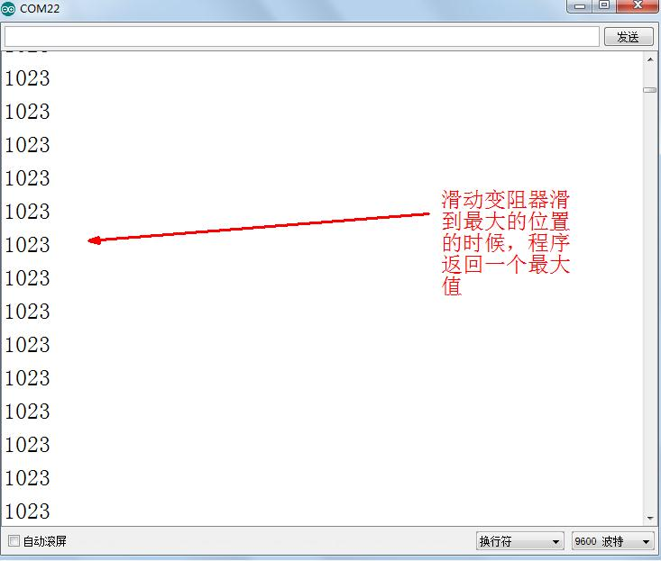
Resources
- Sliding Potentiometer Eagle File
- Sliding Potentiometer in PDF
- Sliding Potentiometer datasheet
Support
If you have questions or other better design ideas, you can go to our forum or wish to discuss.

